Sign in page for the main dashboard  
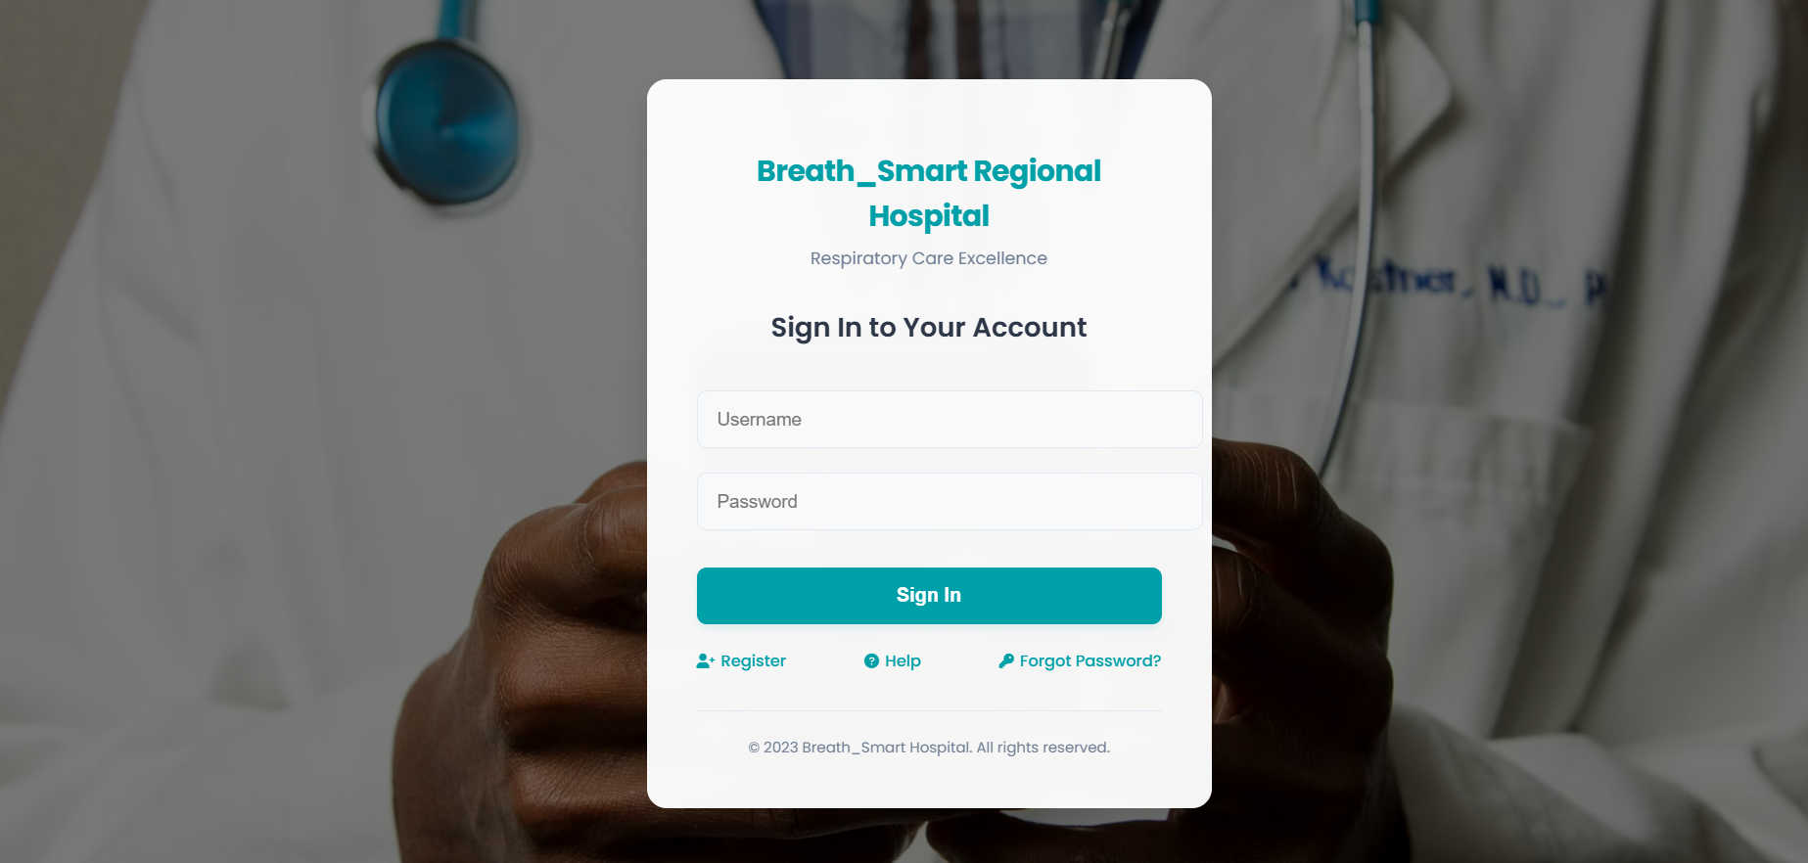

Main Dashboard:

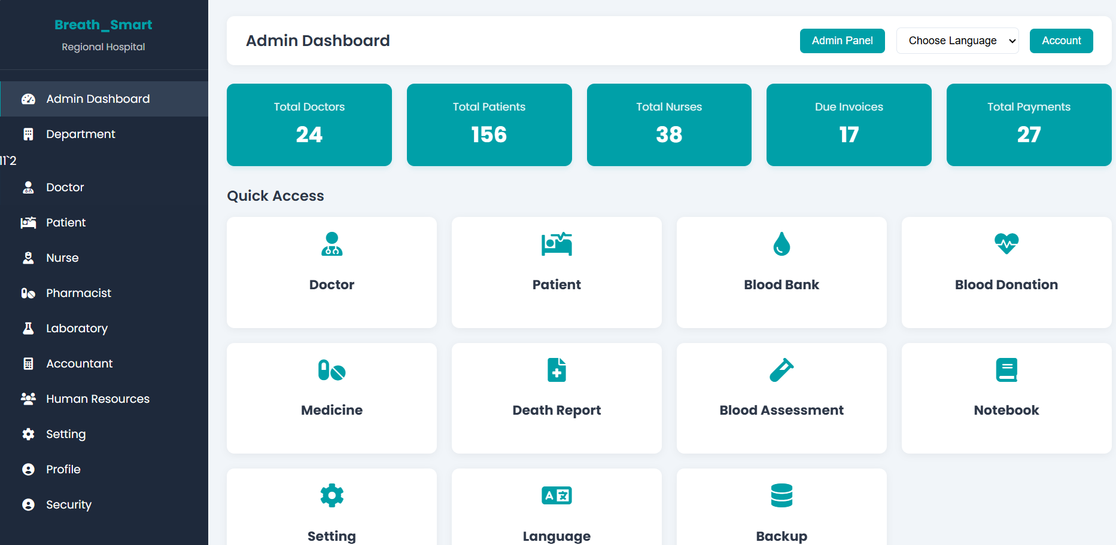

Department:  
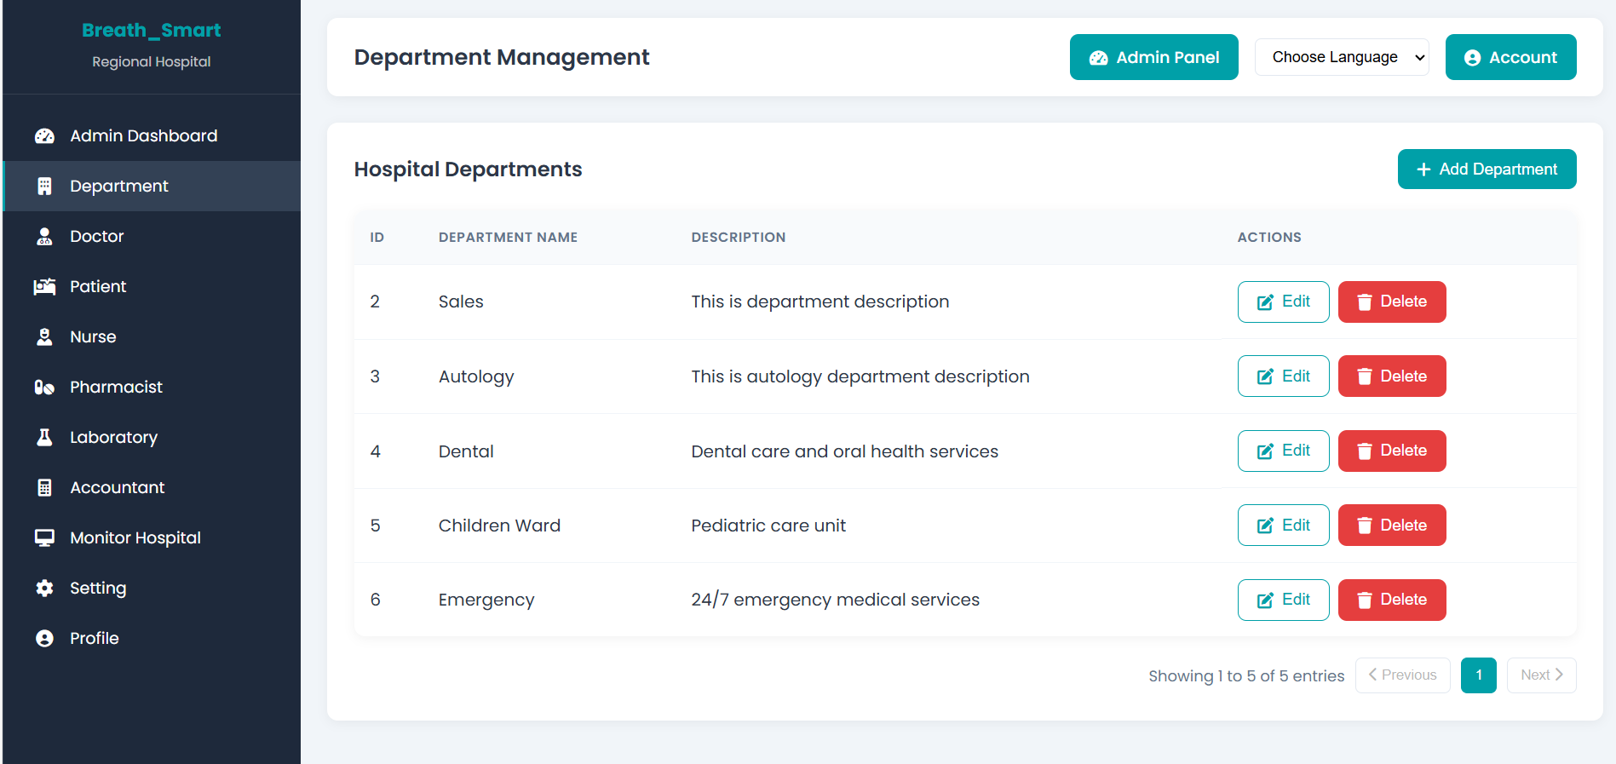

Doctor:

Sign page to Patient Dashboard:  
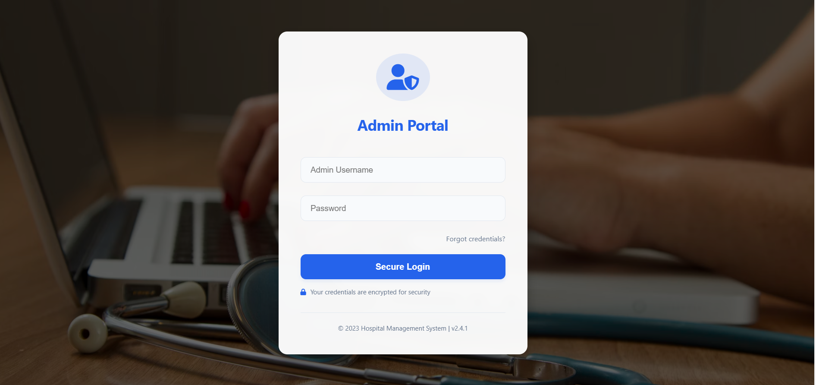

Patient Dashboard:  
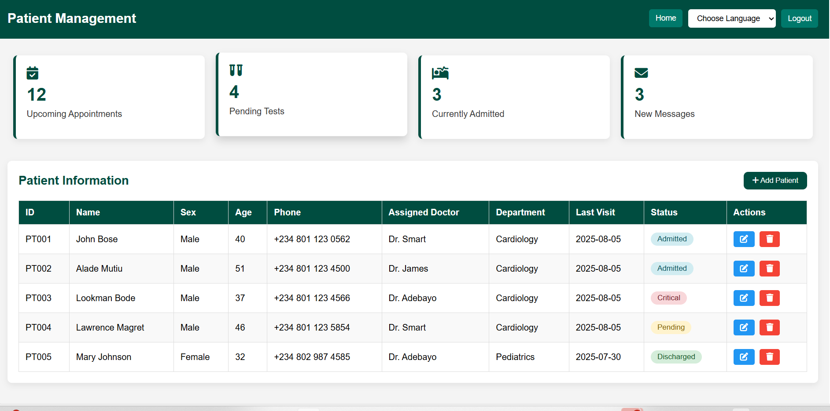

Nurse Dashboard:  
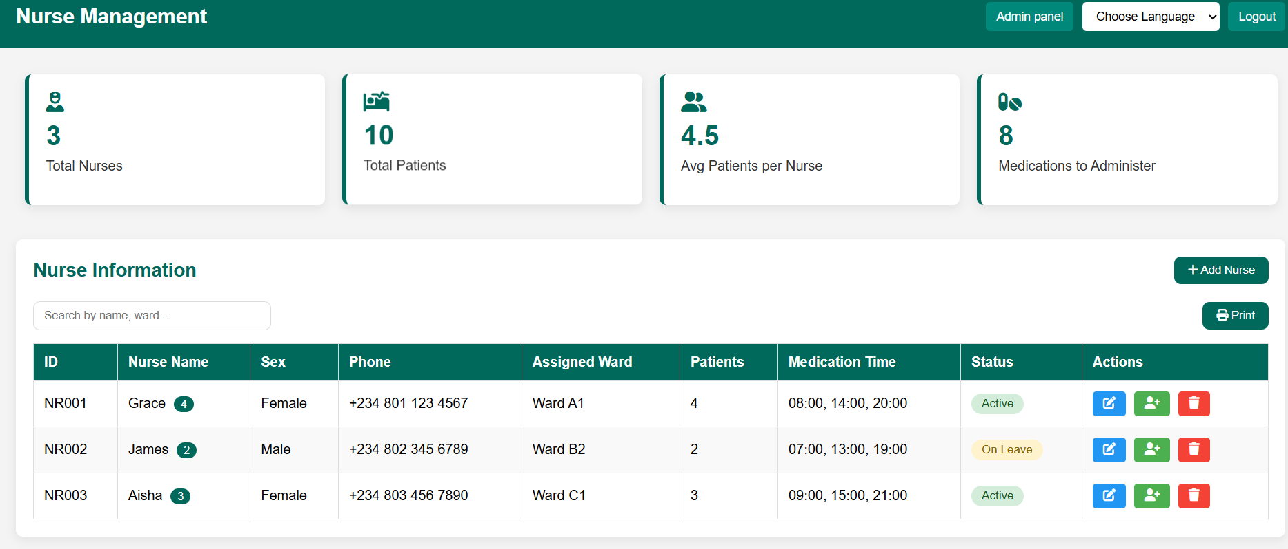

Pharmacist:   
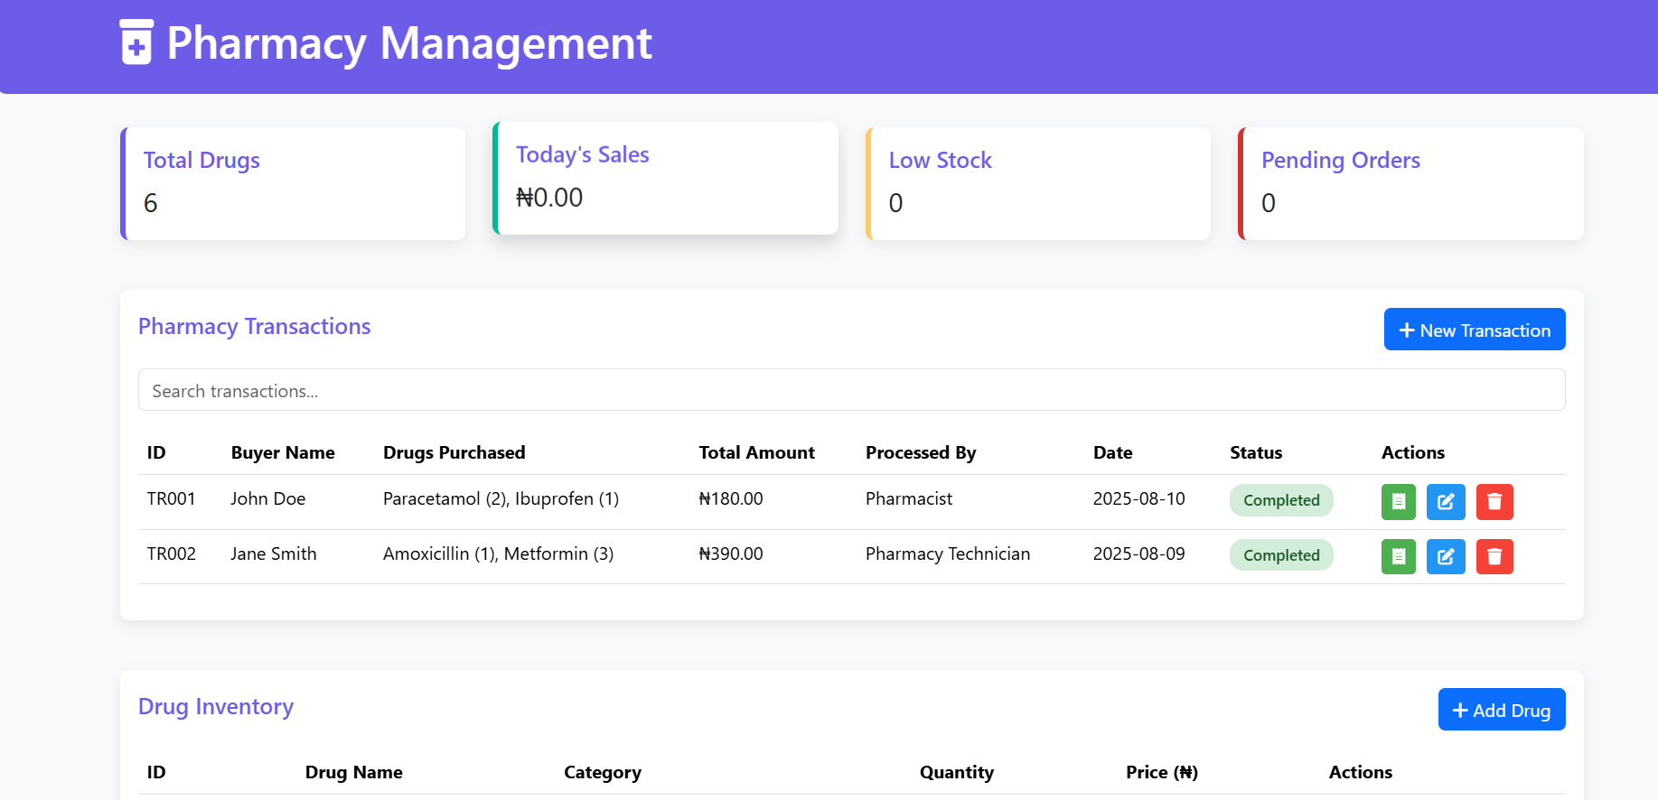

Laboratory Dashboard: 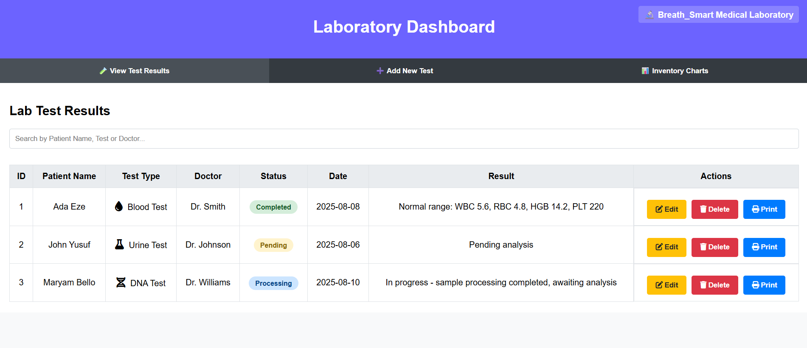

Accountant login:  
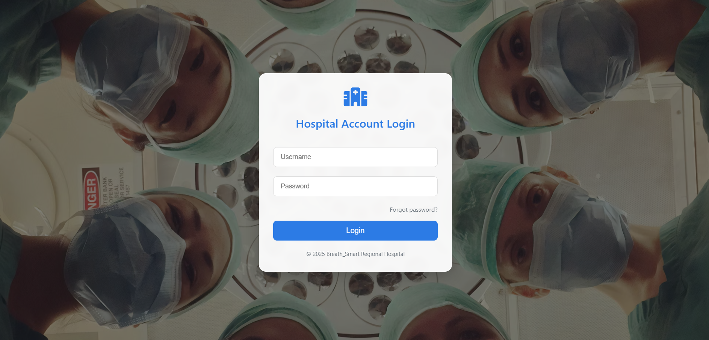

Accountant Dashboard:

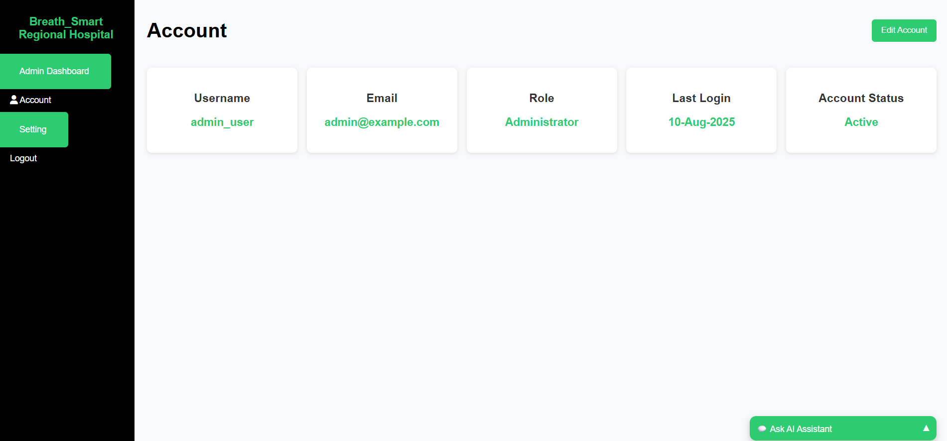

Human Resources Dashboard:   
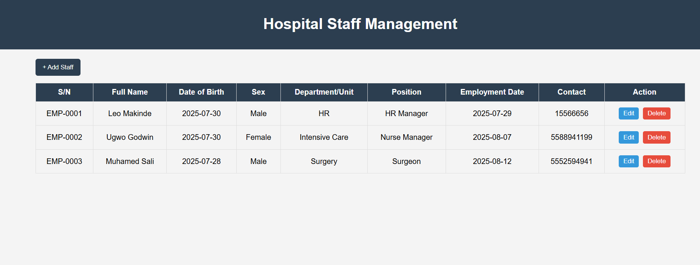  
Help/Emmergency Dashboard:  
